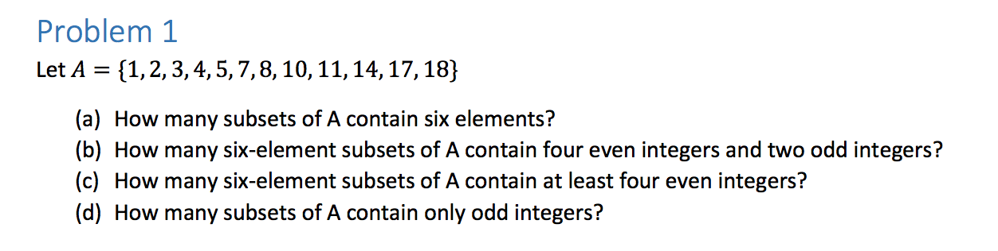

1. 12 elements, six chosen.

6A12 = 12! / 6! 6! = 665280 / 6\*5\*4\*3\*2 = 924 subsets

1. (64) (62) = ( 6! / 4!2! ) (6! / 4!2!) = (6! / 48) (6! / 48) = 15 \* 15 = 225 subsets
2. (64)(62)+ (65)(61) + (66)(60) + = 225 + 36 + 1 = 262 subsets.
3. (61) + (62) + (63) + (64) + (65) + (66) = 924 subsets

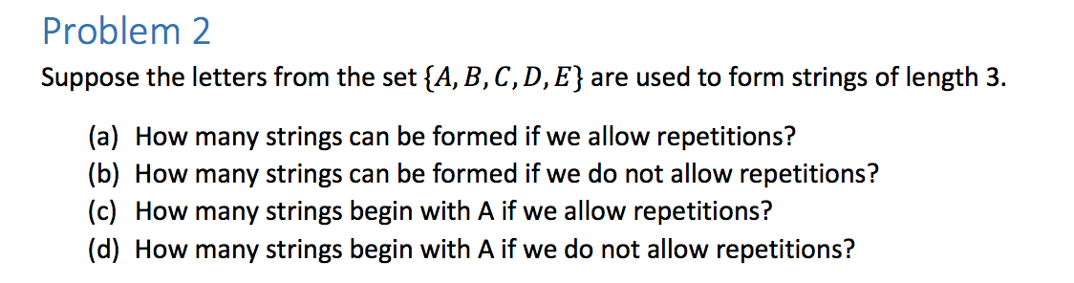

1. 53 = 125 strings
2. 5! / (5-3)! = 120 / 2 = 60 strings
3. 52 = 25 strings
4. 4\*3 = 12 strings

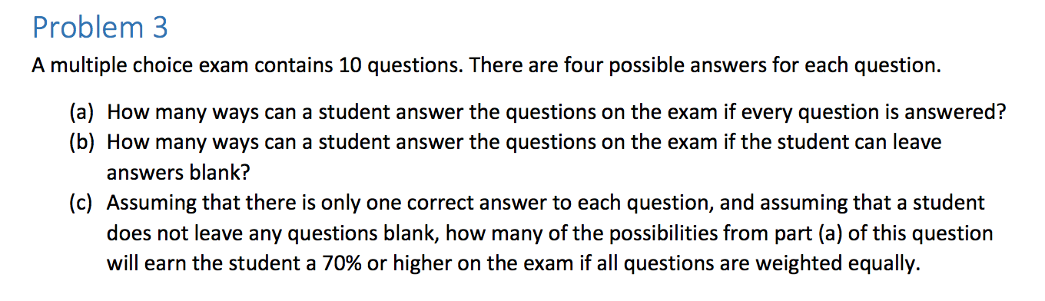

1. 410 = 1, 048, 576 ways.
2. 510 = 9, 765, 625 ways.
3. (10 7)\*3 \* 3 \* 3 + (10 8) \* 3 \* 3 + (10 9) \* 3 + (10 10) = 10\*9\*8 / 6 (27) + 10\*9/2 (9) + 10\*3 + 1 = 3240 + 405 + 31 = 3676 ways.

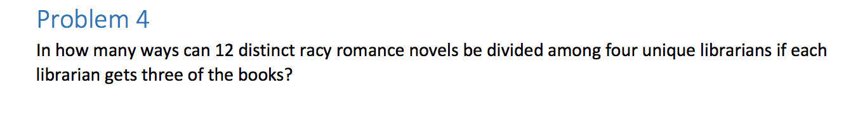

12 books, three books each, four people.

Combos to get three books for 12 people \* combos to get 3 books for 9 people \* combos to get 3 books for 6 people \* combos to get 3 books for 3 people.

(123)(93) (6 3) (3 3) = 369, 600 ways.

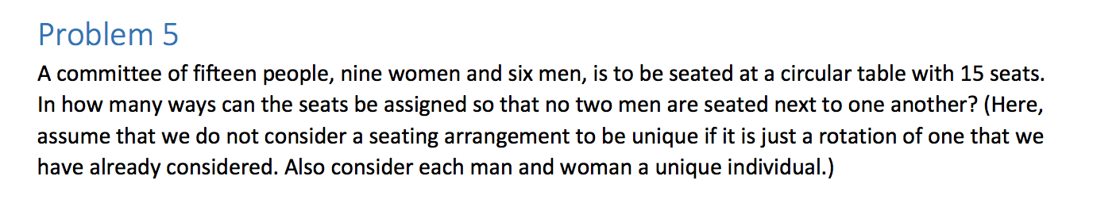

So each combo will produce 15 of the same rotations, so you’ll have to divide by 15 in the end. Group together one woman and one man, because if no two men sit next to each other, each man must sit next to a woman. This creates a new set because they have to sit together.

If we decide a man sits at the head of the table, there are 6 ways to do this. Then, if we continue looping around the table, we have 9 ways to put a woman next to them. Then, as we keep looping around the table, each man and woman possibility decrease by 1.

Since each of the rotations is the same thing, you have to divide 9! / 9 = 8!. Any of the spare 3 women can be placed in between each of men spots.

(96)6!8! = 2438553600 ways.

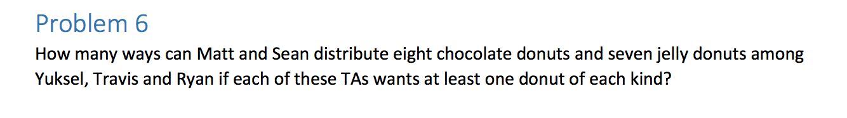

If we partition the donuts, the chocolate kind has seven places where a bar could go, and three people do divide it into.

(72) = 7! / 2! 5! = 7\*6 / 2 = 21 ways for chocolate

If we partition the jelly donuts, the jelly kind has six places where a bar could go and three people to divide into.

(62) = 6! / 2!4! = 6\*5 / 2 = 15 ways for jelly

To get combinations of both, 21 \* 15 = 315 ways.